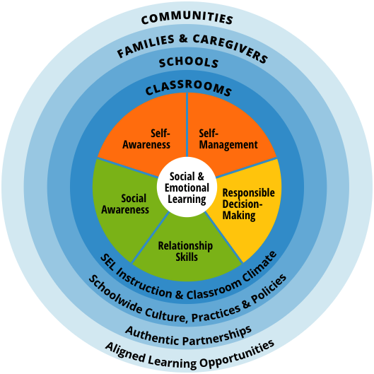

SEL Competencies¹

•Self-awareness: The ability to accurately recognize one’s emotions and thoughts and their influence on behavior. This includes accurately assessing one’s strengths and limitations and possessing a well-grounded sense of confidence and optimism.
•Self-management: The ability to regulate one’s emotions, thoughts, and behaviors effectively in different situations. This includes managing stress, controlling impulses, motivating oneself, and setting and working toward achieving personal and academic goals.
•Social awareness: The ability to take the perspective of and empathize with others from diverse backgrounds and cultures, to understand social and ethical norms for behavior, and to recognize family, school, and community resources and supports.
•Relationship skills: The ability to establish and maintain healthy and rewarding relationships with diverse individuals and groups. This includes communicating clearly, listening actively, cooperating, resisting unwanted or inappropriate social pressure, negotiating conflict constructively, and seeking and offering help when needed.

•Responsible decision making: The ability to make constructive and respectful choices about personal behavior and social interactions based on consideration of ethical standards, safety concerns, social norms, the realistic evaluation of consequences of various actions, and the well-being of self and others.

______________
1 Collaborative for Academic, Social, and Emotional Learning. (2015). Social and emotional learning core competencies. Chicago, IL: Author. Retrieved from casel.org/social-and-emotional-learning/core-competencies/

